Equality impact assessment

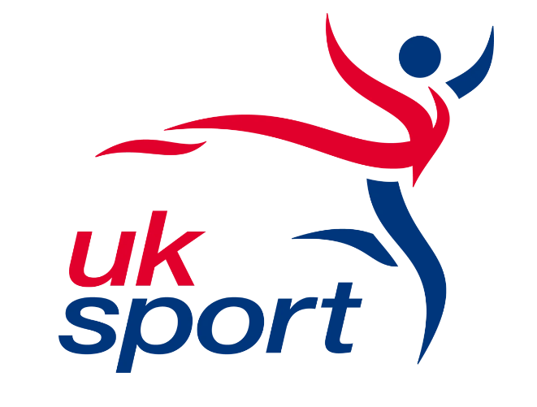 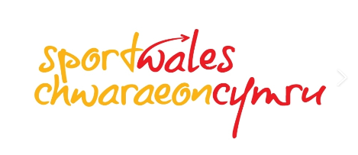 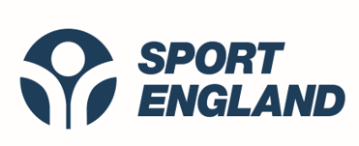 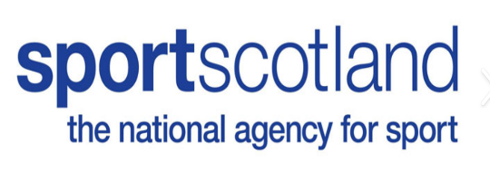 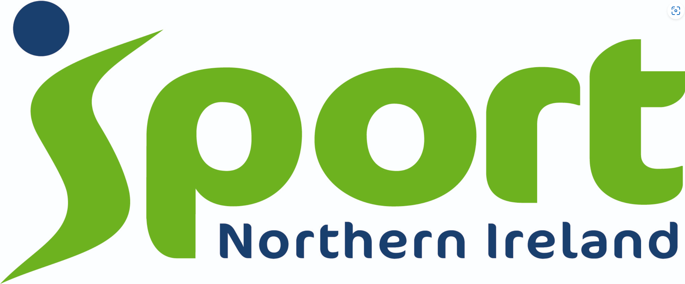

**Moving to Inclusion Framework**

**Section 1 – Description of project**

|  |
| --- |
| **Background** The first ever Equality Standard for Sport was launched in November 2004 with a review taking place in 2012.  In 2020/2021, the Sport's Councils Equality Group (SCEG) commissioned a comprehensive review, involving widespread consultation with the sport and physical activity sector, to ensure it was sufficiently progressive and fit for purpose.  SCEG is a working group with representation from all UK based Sports Councils aiming to promote and develop equality, diversity and inclusion (ED&I) in sport and physical activity. The outcome of the review led to the creation of the Moving to Inclusion Framework - a new supportive development tool.  Moving to Inclusion guides organisations on developing inclusive practice through self-reflection and continuous improvement. This programme aims to embed equality, diversity, and inclusion (ED&I) through incorporating action planning, implementation, and review into an organisation's everyday work.  No two organisations are alike, and all organisations are at different stages on their ED&I journey. The starting point and continuous improvement plan will therefore be bespoke to each organisation, based on their particular needs identified through the self-reflection process. This will help ensure that every organisation has the opportunity to promote and develop ED&I in sport and physical activity.  The revised framework was a joint project of the Sports Council Equality Group (SCEG), comprising UK Sport, Sport England, **sport**scotland and Sport Wales.  **Target audience**  The primary audience for the revised framework is those sports, physical activity and movement organisations that receive funding from the Sports Councils. Each Sports Council will determine priorities for enhanced support through mentors, but it is open to all through the website hub. |

**Section 2 – General impacts of the project**

|  |
| --- |
| Moving to Inclusion is an organisational development tool consisting of a framework of 5 development pillars. These comprise:   * Leadership * Culture * Experience * Relationships * Communications   Within each pillar are a series of self-reflection diagnostic indicators that enable an organisation to consider areas of strength and areas for improvement. The framework provides supportive suggestions for improvement in these self-identified areas which feed into continuous improvement planning and implementation as outlined in the process visual below:  An image of a diagram of the process of improvement. The image includes central text 'policy into practice' with text of the following stages in the process:  'Set up a working group' 'Establish or review EDI policy' 'Self-Reflection diagnostic' 'Continuous Improvement Plan' 'Implementation' 'Review of Progress'  Organisations would look to implement the Moving to Inclusion framework over a four-year cycle, with reviews on progress taking place annually.  Support available – Enhanced Improvement Package:  Any sport and physical activity organisation can access the Moving to Inclusion Framework utilising the self-reflection diagnostic tool and continuous improvement plan template. The Moving to Inclusion website provides additional resources and online guidance to further support with the ‘how’.  The Sports Councils of the United Kingdom can provide additional support to organisations or funded partners aligned to their strategic objectives and based on the needs of the organisation. Support available in this Enhanced Improvements Package includes:  Mentoring to support the continuous improvement planning process – Sports Councils can assign an organisation a mentor or connect them with a peer mentoring process. Mentoring is available to support organisations’ working groups to understand further the results of self-reflection, and guide towards solutions for change to include in the continuous improvement plan. The bank of mentors are experts in ED&I, and are there to support working groups through facilitation, being a critical friend and signposting.  Mentoring to support the review process – The mentor will revisit the organisation annually to support a review of progress. They will facilitate discussions and guide solutions to overcome challenges or maximise success further. At an appropriate time, (within a 4 year cycle), the mentor will support a formal review of progress, revisiting the self-reflection diagnostic tool, facilitating learning, and supporting adjustments to an organisation’s Continuous Improvement Plan.  Communities of Practice – Based on pillars or specific themes, communities of practice will be co-ordinated to bring together organisations to share what is working, support one another to learn from what might not be working and explore the potential to collaborate on ideas to identify solutions.  The Sports Councils will be responsible for monitoring the review process for their partners engaged with the framework.  **Aims and impact:**  Moving to Inclusion is intended to drive meaningful change in practice, tackling inequalities, leading to sustainable improvements in the representation, diversity, and positive inclusive experiences for leaders, the wider workforce, and participants in sport and physical activity.  The initial impact therefore of Moving to Inclusion is on national partners. The work national partners do benefits people participating in sport and physical activity across the UK at all levels. Participants are effectively the staff and wider stakeholders of the organisation. |

**Section 3 – Evidence**

|  |
| --- |
| The Equality Standard for Sport was introduced in 2004 to address inequalities within the sport and physical activity sector. There is a wide body of research which outlines the inequalities which exist in sport, across all protected characteristics. As part of the independent review, specific additional research was undertaken to understand the sector position. This included a review of Sport Council strategies, data, investments as well as a review of other sector quality systems / accreditations and legislation. This spanned the entire 16 years of the Standard. A full list of documents and evidence reviewed to inform the new framework can be found in Appendix C.  **Evidence of impact - Previous equality standard**  Equality Standard Achievements and Key Dates Timeline shown below gives an overview of the number of organisations that have achieved the different levels of the Equality Standard as well as some relevant key dates from the sector.  **A diagram showing the Equality Standard Achievements and Key Dates Timeline and an overview of the number of organisations that have achieved the different levels of the Equality Standard as well as some relevant key dates from the sector.**  The lack of available data since the start of the Equality Standard in 2004 makes it hard to quantify the impact of the Standard on the sector. With the home nations not having a standardised method of measurement of participation in sport split by demographics, it is not possible to cross reference across the nations. England is the only home nation to collect full sports participation data with the Active People survey which was launched in 2005. The survey was reviewed in 2015 and became Active Lives. There is “participation in physical activity and sport in the last four weeks” data for Scotland between 2007 and 2018 from the Scottish household survey 2018: annual report. However, data is not split by the different equality groups over time. The only data about participation in Wales goes back to 2016/17. We have received no participation data for Northern Ireland.  To give an indication of possible trends, we have observed the following based on the Sport England Active People Survey. There was very little change in once a week participation across any of the equality groups in England between 2005 and 2016. Overall, there were increases leading up to 2012/13. However, participation then returned back just above the 2005/06 levels in 2015/16.  Image showing the trend from the Sport England Active People survey showing the trend data explained in the previous narrative.  Most equality groups had the highest participation levels in either 2011/12 or 2012/13 which corresponds with a large increase in the number of organisations that achieved the framework, especially at foundation level. It also corresponds with the London 2012 Olympic and Paralympic Games, at which time there was a significant drive in grassroots participation.  The greatest positivity and change are seen within organisations going through the advanced level of the Standard, where full organisational buy in and commitment is essential. Only 7 organisations have achieved this level since the Standard was introduced, and the majority of those have been in the last 2 years. It is at this level that a holistic approach is taken to tackling inequalities that enables an organisation to identify gaps in its practice and embed new ways of working. The greatest success of embedding changes is seen in organisations that decide they are committed to improving their equality, diversity and inclusion and recognise the Standard as a tool to do this.  Scotland has seen the greatest success with embedding the Equality Standard as part of their delivery system and has seen the highest number of organisations achieving. Scottish bodies are also the most positive about the Standard, scoring all elements of the Standard higher than their English counterparts. Achieving the Standard remains mandatory in Scotland.  **Other home countries – list of research / data sources, sense check**  As the Moving to Inclusion framework has developed, we recognise the continuing evidence and research undertaken to explore equality, diversity and inclusion in sport. This has emphasised issues of inequality, lack of diversity and poorer experiences of taking part for people who share protected characteristics across sport and physical activity. Examples include the  Tackling Racism and Racial Inequality in Sport research and Sport England’s ‘Spotlight on [Lower socio-economic groups | Sport England](https://www.sportengland.org/research-and-data/research/lower-socio-economic-groups) |

**Section 4 – Differential impacts and opportunities**

Consider whether the project, programme or service might have different impacts on one or more groups, or whether there are opportunities to improve equality.

|  |  |
| --- | --- |
| **Age: older people / children & young people** | Participation in sport is shown to decrease with age.  There is a potential positive impact as national partners increase their understanding of the barriers to participation for different age groups in their sport, they may be able to develop specific initiatives/actions to address these. There may also be a potential positive impact on an organisation’s workforce. This would be dependent on the outcomes from the diagnostic tool and the support/direction received from the sport’s mentor.  There may be a potential negative impact should a national partner decide not to progress with recommendations from the diagnostic tool, where these are focused on supporting different age groups in their sport. Any concerns over decision making process would be communicated to Sport Councils by the specified mentor.  There may not be the capacity and access to specialist skills from a relevant equality partner in this area. This may result in delays to progressing actions. |
| **Disability** | Disabled people are less likely to participate in sport.  There is a potential positive impact as national partners increase their understanding of the barriers to participation for disabled people in their sport, they may be able to develop specific initiatives/actions to address these. There may also be a potential positive impact on the organisation’s workforce. This would be dependent on the outcomes from the diagnostic tool and the support/direction received from the sport’s mentor.  The systems and resources provided to national partners as part of the framework will be fully accessible.  There may be a potential negative impact should a national partner decide not to progress with recommendations from the diagnostic tool, where these are focused on supporting disabled people in their sport / organisation. Any concerns over decision making process would be communicated to Sport Councils by the specified mentor.  There may not be the capacity and access to specialist skills from a relevant equality partner in this area. This may result in delays to progressing actions. |
| **Gender Reassignment** | Transgender people are less likely to participate in sport.  Transgender inclusion in sport is a complex and evolving area and there may be differences in opinion from equality partners. Specific sports council guidance (itself, the subject of a separate Equality Impact Assessment) is available to help organisations create their own transgender participation policies which will have an impact on the opportunities for transgender people to participate in domestic sport.  In respect of this Framework, there is a potential positive impact as national partners increase their understanding of the barriers to participation for transgender people in their sport, they may be able to develop specific initiatives/actions to address these. There may also be a potential positive impact on an organisation’s workforce. This would be dependent on the outcomes from the diagnostic tool and the support/direction received from the sport’s mentor.  There may be a potential negative impact should a national partner decide not to progress with recommendations from the diagnostic tool, where these are focused on supporting transgender people in their sport / organisation. Any concerns over decision making process would be communicated to Sport Councils by the specified mentor.  There may not be the capacity and access to specialist skills from a relevant equality partner in this area. This may result in delays to progressing actions. |
| **Marriage and civil partnerships** | We are not aware of any published evidence which suggests that the framework would impact people differently due to their marital status. |
| **Pregnancy and Maternity** | We are not aware of any published evidence which suggests that pregnant women or women on maternity leave would be impacted differently by the framework. |
| **Race** | People from diverse ethnic communities are less likely to participate in sport.  There is a potential positive impact as national partners increase their understanding of the barriers to participation for people from diverse ethnic communities in their sport, they may be able to develop specific initiatives/actions to address these. There may also be a potential positive impact on the organisation’s workforce. This would be dependent on the outcomes from the diagnostic tool and the support/direction received from the sport’s mentor.  There may be a potential negative impact should a national partner decide not to progress with recommendations from the diagnostic tool, where these are focused on supporting people from diverse ethnic communities in their sport / organisation. Any concerns over decision making process would be communicated to Sport Councils by the specified mentor.  There may not be the capacity and access to specialist skills from a relevant equality partner in this area. This may result in delays to progressing actions. |
| **Religion and Belief** | There is a potential positive impact as national partners increase their understanding of the barriers to participation for people who have religious beliefs in their sport, they may be able to develop specific initiatives/actions to address these. There may also be a potential positive impact on the organisation’s workforce. This would be dependent on the outcomes from the diagnostic tool and the support/direction received from the sport’s mentor.  There may be a potential negative impact should a national partner decide not to progress with recommendations from the diagnostic tool, where these are focused on supporting people who have religious beliefs in their sport / organisation. Any concerns over decision making process would be communicated to Sport Councils by the specified mentor.  There may not be the capacity and access to specialist skills from a relevant equality partner in this area. This may result in delays to progressing actions. |
| **Sex: women and Men** | Women are less likely to participate in sport than men.  There is a potential positive impact as national partners increase their understanding of the barriers to participation for women in their sport, they may be able to develop specific initiatives/actions to address these. There may also be a potential positive impact on an organisation’s workforce. This would be dependent on the outcomes from the diagnostic tool and the support/direction received from the sport’s mentor.  There may be a potential negative impact should a national partner decide not to progress with recommendations from the diagnostic tool, where these are focused on supporting women in their sport / organisation. Any concerns over decision making process would be communicated to Sport Councils by the specified mentor.  There may not be the capacity and access to specialist skills from a relevant equality partner in this area. This may result in delays to progressing actions. |
| **Sexual Orientation** | People who are part of the LGBQI+ community are less likely to participate in sport.  There is a potential positive impact as national partners increase their understanding of the barriers to participation for people due to their sexual orientation in their sport, they may be able to develop specific initiatives/actions to address these. There may also be a potential positive impact on an organisation’s workforce. This would be dependent on the outcomes from the diagnostic tool and the support/direction received from the sport’s mentor.  There may be a potential negative impact should a national partner decide not to progress with recommendations from the diagnostic tool, where these are focused on supporting people due to their sexual orientation in their sport in their sport / organisation. Any concerns over decision making process would be communicated to Sport Councils by the specified mentor.  We recognise that the transgender community often sits within the wider LGBQI+ community which means that there could be both positive and negative impacts as stated above.  There may not be the capacity and access to specialist skills from a relevant equality partner in this area. This may result in delays to progressing actions. |

**Section 5 – Stakeholder engagement**

|  |
| --- |
| In addition to the desk-based research carried out, the following stakeholder engagement was also undertaken to inform the new framework with 89 organisations:  **Online surveys -** An online survey was sent to 50 recipients, who had all expressed an interest to their home nation sports council in being part of this evaluation. The survey was also circulated via e-newsletter by each of the sports councils directly to National Governing Bodies, Active Partnerships and equality partners. The survey link was also shared via LinkedIn. This enabled a wider consultation to individuals who would have engaged with the Standard over the last 16 years. This perspective would give us the opportunity for valuable insight into the early days of the Standard.  **Semi-structured interviews -** 12 semi structured interviews were completed covering each of the Sports Councils, the members of SCEG, the equality partners as well as additional organisations who were able to provide valuable insight into the Standard. Four additional interviews were carried out with representatives from quality systems/accreditations outside of the sector to understand what makes them successful, lessons that have been learnt in recent reviews, and how they are promoted or enforced.  **Focus groups -** Three focus groups with the Designated Support Leads (DSLs) and Equality Standard Assessors (EQSAs), to understand their views. Whilst the number of DSLs and EQSAs is small, multiple sessions were set up to ensure that everyone was able to attend.  **Deep dive interviews -** The independent consultants carried out a number of ‘deep dive’ interviews with several organisations regarding their engagement with the previous Equality Standard for Sport. The aim was to understand their experiences of progression and assessment, their process for working through the Standard within their organisation, the benefits that they feel they have gained and suggested improvements. The interviews also looked to understand how they have cascaded the work throughout the sport or geographical area and to understand any other frameworks with which they have engaged. Organisations involved in this stage included: Badminton England; Commonwealth Games Scotland; UK Athletics; Disability Sport Wales; Swim England and British Swimming (from the perspective of Swim England); Youth Sport Trust; Kent Sport; Scottish Volleyball and England and Wales Cricket Board.  **Future engagements**  There will be opportunities to share the new proposed framework with members of SCEG and throughout each home Sports Council. There will also be opportunities to share externally with national partners and equality partners to engage in the new framework. This will be dependent on each home country.  **Impact assessment**  We will share the draft equality impact assessment with key stakeholders. |

**Section 6 – Actions**

|  |  |
| --- | --- |
| **Action** | **Timelines** |
| Carry out inclusive recruitment for mentor roles to ensure a diverse cohort across the UK. | June – July 2023 |
| Deliver training and orientation for mentor roles | July – August 2023 |
| Briefing sessions on the new framework and guidance with all Sports Councils key internal staff prior to publication of the guidance (home country dependent). | July – December 2023 |
| Briefing sessions on the new framework and guidance with all equality partners and national partners prior to publication of the guidance (home country dependent). | July – December 2023 |
| SCEG to identify first cohort of national partners to transition over to new Moving to Inclusion framework from Equality Standard in Sport. | June – December 2023 |
| Review initial roll out of new framework to first cohort for learning. Identify and implement any necessary improvements. | January 2024 – March 2024 |
| Bring mentors together to share best practice and challenges from national partners | Dependent on roll out. Timeline to be confirmed. |

**Section 7 – Sign off**

|  |  |
| --- | --- |
| **Assessment signed off by** | Sports Councils Equality Group and sportscotland senior management team |
| **Sign off date** | January 2024 |

**Appendix one – Desk based research to inform new framework**

|  |  |  |  |  |  |  |
| --- | --- | --- | --- | --- | --- | --- |
| **Doc Ref.** | **Title of Document** | **SCEG Group Relating to** | | **Year** | | **Link to file / URL** |
| 1 | Equality Act 2010 | All (UK Gov) | | 2010 | | https://www.legislation.gov.uk/ukpga/2010/15/contents |
| 2 | Sporting Future - a new strategy for an active nation | All (UK Gov) | | 2015 | | https://www.gov.uk/government/publications/sporting-future-a-new-strategy-for-an-active-nation |
| 3 | Playing to Win 2008 | DCMS | | 2008 | | https://dera.ioe.ac.uk/7626/7/DCMSplayingtowin_Redacted.pdf |
| 4 | Game Plan 2002 | DCMS | | 2002 | | http://www.gamesmonitor.org.uk/files/game_plan_report.pdf |
| 5 | Sport England Active Lives | Sport England | | 2016 | | https://www.sportengland.org/know-your-audience/data |
| 6 | Sport England Active People | Sport England | | 2006 | | https://activepeople.sportengland.org/ |
| 7 | Sport For All insight report: | Sport England | | 2020 | | https://www.sportengland.org/news/sport-for-all |
| 8 | SE Strategy Review: | Sport England | | 2020 | | https://www.sportengland.org/why-were-here/shaping-our-future-strategy |
| 9 | Towards an Active Nation | Sport England | | 2016 | | https://sportengland-production-files.s3.eu-west-2.amazonaws.com/s3fs-public/sport-england-towards-an-active-nation.pdf?zE6hDbFaa9dNK8tRqxP2HuVIM2Ls79HG |
| 10 | Volunteering strategy | Sport England | | 2017 | | https://www.sportengland.org/campaigns-and-our-work/workforce#volunteering |
| 11 | Coaching strategy | Sport England | | 2017 | | https://www.sportengland.org/campaigns-and-our-work/workforce#coaching |
| 12 | Professional Workforce strategy | Sport England | | 2017 | | https://www.sportengland.org/campaigns-and-our-work/workforce#professional_workforce |
| 13 | Workforce funding | Sport England | | 2020 | | https://www.sportengland.org/news/ps1-million-diversify-sport-and-physical-activity-workforce |
| 14 | SE Strategy 2012-2017: A Sporting Habit For Life | Sport England | | 2012 | | https://sportengland-production-files.s3.eu-west-2.amazonaws.com/s3fs-public/a-sporting-habit-for-life-a4-1.pdf |
| 15 | Sport England NGB: Whole Sport Plan Investment Guidance 2013-17 | Sport England | | 2013 | | https://assets.publishing.service.gov.uk/government/uploads/system/uploads/attachment_data/file/79233/NGB_2013_17_Whole_Sport_Plan_Investment_Guidance.pdf |
| 16 | SE Strategy 2008-2011 | Sport England | | 2008 | | https://www.britishrowing.org/upload/files/Partners/SptEngStrat2008-11.pdf |
| 17 | SE Diversity Action Plan | Sport England | | 2017 | | https://sportengland-production-files.s3.eu-west-2.amazonaws.com/s3fs-public/sport-england-diversity-action-plan.pdf |
| 18 | The Framework for Sport in Eng-land 2004 | Sport England | | 2004 | | http://www.lancasterrowing.co.uk/national-framework-for-sport.pdf |
| 19 | Scottish Household Survey col-lects data on sport participation for adults. They have collected this since 2008, previously sportscotland collected this par-ticipation data. | | Sport Scotland | | Link to latest 2018 report – sport and physical activity data in Chapter 8 | |
| 20 | Sport for Life: Sport Scotland Corporate Strategy | Sport Scotland | | Apr-19 | | https://sportscotland.org.uk/media/4713/sport-for-life-full-document.pdf |
| 21 | Sport 21 | Sport Scotland | | 2003 | | https://sportscotland.org.uk/documents/resources/sport2120032007.pdf |
| 22 | Single Equity Scheme: Promoting Equality of Opportunity in Sport, sportscotland, 2007. | | Sport Scotland | | 2007 | |
| 23 | Raising the Bar | Sport Scotland | | 2015 | | https://sportscotland.org.uk/media-imported/1568147/raising-the-bar-corporate-plan-2015-19-lweb.pdf |
| 24 | Developing and supporting a world class sporting system | Sport Scotland | | 2011 | | https://sportscotland.org.uk/documents/publications/aworldclasssportingsystem.pdf |
| 25 | Equality Mainstreaming and out-comes report | Sport Scotland | | 2019 | | https://sportscotland.org.uk/media/4712/final-2017-19-equality-mainstreaming-and-outcomes-report.pdf |
| 26 | Equality Outcomes | Sport Scotland | | 2017 | | https://sportscotland.org.uk/media/2591/equality-outcomes-2017.pdf |
| 27 | Our Plan: Sport Scotland | Sport Scotland | | 2007 | | https://sportscotland.org.uk/documents/resources/sportscotlandcorporateplan20072011.pdf |
| 28 | Active Lifestyles Survey | | Sport Wales | | https://www.sport.wales/content-vault/sport-and-active-lifestyles-survey/ | |
| 29 | School Sport Survey | | Sport Wales | | https://www.sport.wales/content-vault/school-sports-survey-2018/ | |
| 30 | Older National Survey Responses | | Sport Wales | | https://www.sport.wales/content-vault/statistics/ | |
| 31 | The Vision For Sport in Wales (2018) | Sport Wales | | 2018 | | https://www.sport.wales/our-vision-for-sport/ |
| 32 | Enabling Sport in Wales to Thrive | Sport Wales | | 2019 | | https://www.sport.wales/sport-wales-strategy/ |