Non-protected
Equality impact assessments
Places

Name of policy:

Introduction
Lead officer | David Ewart
Others involved in the assessment | Mark Cowan, Graham Finnie, Steven Anderson & Lorraine Jones, Darren McKay
Date(s) of assessment | March 2017

Description of policy
Background | This EQIA covers the full breadth of the facilities team’s work, including:  - Facilities Investment: Investing strategically, through the Sports Facilities Fund (SFF) in school and education, club and community, and performance sport facilities projects, where the need and impact is greatest and the outcomes are clear.  - Facilities Design: Developing and promoting sportscotland’s expert resource in the design, construction of sports facilities  - Facilities Planning: Providing strategic planning advice and support to partners to ensure that a more integrated approach is taken to the planning and development of sports facilities across Scotland. Using our role in the statutory planning process to protect and improve the quality and capacity of playing fields and pitches
Purpose and outcomes | Places is an Enabler within sportscotland’s 2015-19 corporate plan. The purpose and outcomes of each of the three areas of work is designed to ensure that everyone will have access to a network of quality places where they can get involved in sport.  - Facilities Investment: for example investing strategically in a network of National and Regional sports facility projects that provide training and competition facilities to meet the needs of Scottish Governing Bodies (SGBs) of sport.  - Facilities Design: for example publishing and promoting advice and guidance such as technical data sheets and project case studies that promote good design and knowledge to sports clubs, SGBs and local authorities.  - Facilities Planning: for example as statutory consultee on planning applications affecting playing fields, protecting the loss and/or negotiating enhancement in the standard, quality, capacity and sustainability of sports pitches threatened by other forms of development such as housing or new schools.
How it links to sportscotland corporate and business plans | sportscotland Corporate Plan 2015-19: Raising the Bar  Places is an Enabler within sportscotland’s 2015-19 corporate plan. The purpose and outcomes of each of the three areas of work is designed to ensure that everyone will have access to a network of quality places where they can get involved in sport. In addition our work with is explicitly referenced within the under four impact measures (numbers 11-14):  11. We will have established sportscotland national centre Inverclyde as a fully-inclusive, residential sports facility.  12. We will have contributed to the successful completion of the National Performance Centre for Sport and integrated it within our high performance network.  13. We will have made places for sport a more integral part of planning for sport, both locally and nationally.  14. We will have targeted our resources around the development of places for sport where they can have the greatest impact on participation and progression in sport.  sportscotland 2017-19 Business Plan  Our places portfolio is focused on developing a network of quality places that provide people with the opportunity to get involved and stay involved in sport. We will prioritise our time, expertise and investment on this objective, and are committed to collaborating with others to achieve it. Our support will be targeted at projects in the school and education, club and community, and performance environments.  Managing investment and the implementation of projects through our Sports Facilities Fund is a core part of what we do. We will support projects that deliver the greatest impact on our participation and progression outcomes, and priorities for improvement.  Over the period of the last plan, we led on the successful delivery of two major capital projects. Firstly, the redevelopment of sportscotland National Sports Training Centre Inverclyde was achieved through substantial dedicated specialist in-house support from across sports development, high performance and corporate services. Looking forward, we are committed to supporting the transition from a successful project build to a world class inclusive, residential sports facility. Secondly, Oriam: Scotland’s Sports Performance Centre was achieved in partnership with Heriot Watt University, supported by specialists from across sports development, high performance and corporate services.  During the period of this plan, we will continue to support projects at a local, regional and national level. At a local level, we are committed to working with clubs and community groups to ensure our support continues to meet their needs. We will support projects that are able to evidence strong community engagement. At a regional level, we will work the key stakeholders to develop regional sports facilities projects in Edinburgh, Dundee and Inverness that meet identified gaps in provision.  At a national level, we will prioritise a number of major capital projects. Firstly, we will support the delivery of a National Curling Centre in Stirling. Secondly, we will lead on the design and delivery of a National Training Centre for Shooting, ensuring that it meets the needs of the key sports involved. Finally, we will work closely with Tennis Scotland and the Lawn Tennis Association on the implementation of a network of indoor tennis centres across the country.  We will continue to play our part in encouraging more SGBs and local authorities to take a more integrated approach to planning for sport. We will add value to this work through the investment of our time and expertise.
How we intend to implement the policy | Facilities Investment – SFF Guidelines and Application process allow external partners to apply for investment in a wide variety of eligible projects to provide new or improved sports facilities. The SFF Assessment process is led by Facilities Development but also involves internal colleagues Sports Development, Legal and Integrated Investment Teams with a defined decision making process centered around our Principles for Investment and Panel meetings, with SGBs increasingly involved strategically in this process such as Scottish Football, Scottish Rugby, and inclusion of others such as Scottish Tennis, Scottish Gymnastics and Scottish Cycling underway. SFF Awards letters with terms and conditions are sent to applicants to sign and accept and project managers ensure compliance with terms and conditions and payment of awards against project expenditure until completion of of projects. SFF Awards are published on sportscotland website.  Facility Design - Technical Working Group – Facilities Development teams leads reviews and updates of existing work and publications and identify gaps for new advice, guidance and case studies with input where appropriate from partners like SGBs or from facilities strategies, for example Scottish Golf.  Facility Planning - Lead through our statutory role in the planning system; influencing the development of spatial policy and local authority and SGB strategy development. This involves responding to consultations on planning applications, development plans and strategic advice and guidance and using the Facilities Planning Model to inform LA and SGB strategic plans.

Who policy is likely to impact on and how
Who will the policy benefit (i.e. who is the customer?) If applicable, you should consider how sportscotland’s investment is spent in the context of this policy. | Customers – Local Authorities; Scottish Governing Bodies of sport, voluntary constituted sports clubs; companies limited by guarantee; SCIOs, charities, community interest companies, social enterprises, schools, colleges and universities etc.  Beneficiaries – The ultimate beneficiary of this policy is people in Scotland who participate or want to participate in sport.
Is it designed to impact on one/some/all people who share a protected characteristic? How? | Investment:  In the Sports Facilities Fund sportscotland’s contribution to a project, particularly club led projects, the award can be higher than 50% proportionately in areas of SIMD deprivation, and the applicant contribution lower to 10% ensure projects are supported in/from these areas. This is highlighted in the SFF Guidelines. Although this is not a protected characteristic sportscotland has committed to reviewing the impact of our work on SIMD areas.  In the review of SFF Guidelines we will focus increasingly on only investing in projects where the need and impact is greatest and the outcomes are clear and that meet our Equality and Inclusion priorities and that deliver outcomes for increasing participation from/for those with protected characteristics e.g. increasing women and girl’s participation.  Design:  Implicitly impacts on sex, disability and age due to industry standards and building requirements, although not currently specifically targeted in other areas we consistently provide advice and guidance which covers all protected characteristics.  Planning:  Not designed to specifically impact on any one or set of particular protected characteristic.
How will customers be involved in the development and roll out of the policy? If no involvement mechanism, how will customer needs be identified and addressed? | Publication of design guidance is usually in anticipation or response to a requirement or gap that is identified by sportscotland, with a SGB or with practitioners in the building and design industry (architects and contractors etc) and sportscotland develops and produces guidance as required. For example through our input to Scottish Golf’s Facility Strategy we produced guidance on the design of golf practice and training areas. We also produce case studies on successful club projects that have received SFF investment by seeking feedback. This sits on our website and Help for Club links to this but could be widened out through our networks and events.  SFF applicants (successful and unsuccessful) e.g. clubs, community organisations, local authorities etc. provide feedback through customer surveys and this information will be collected on an on-going basis.  Reviews and changes to SFF funding guidelines are consulted on through external funding events with these partners/applicants and our experience with implementation of projects with partners/applicants..  By supporting local authority and SGB facility strategy development, we can encourage involvement and LA/SGB consultation with local communities/member clubs.
Which partners will be involved in the development and roll out of the policy and how? | We will continue to use our partnership with all our customers, but in particular our strategic relationship with local authorities and SGBs to ensure the roll out of this policy.

Think about the impact the policy/practice will have on eliminating discrimination, promoting equality of opportunity and fostering good relations between different groups. Also consider whether there is potential for discrimination.
Ref 1 - Equality & Sport Research 2016: https://sportscotland.org.uk/media-imported/1886385/equality-and-sport-research-final-report.pdf
Ref 2 - Active Scotland Outcomes: Indicator Equality Analysis: http://www.gov.scot/Publications/2015/11/9439/3
Ref 3 -Equality in Sport Learning Notes:
http://ssc-sharepoint/eo/eq/Equality%20Evidence%20Reviews/Equality%20in%20Sport%20-%20learning%20notes%20combined%20pdf.pdf
Link to Places Evidence review is here: http://SSC-SHAREPOINT/eo/eq/Equality Evidence Reviews/Equality evidence review - Places - FINAL.docx

Protected characteristic | What do we know about this group in the context of this policy? | What is the potential impact (positive, neutral and negative) on people who share the characteristic? | What could we do to reduce any negative impacts, maximise positive impacts and ensure quality information?  What further evidence should we collect?
Age | 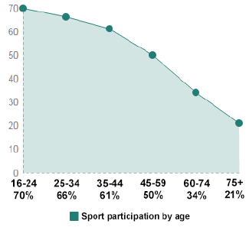(Ref 3)  Participation in sports is highest in 16-24 age group and declines steeply after age 45.  The decrease in participation with age suggests that facility usage is likely to decrease with age.  Key barriers for older people include: lack of local access; cost; and/or; access to transport to facilities.  Intersectionality i.e. older people are more likely to have a disability and/or a limiting long-term illness that limits participation in similar ways a disability could.  Sport-specific participation trends means that facility decisions are likely to impact more or less on certain ages (i.e. bowls for example has higher participation amongst older people.)  Less car-centric places are more important to older people.  Our SFF investment application forms collect information about the age of current and projected users broken down by Under 16 and 16+.  The FPM models participation and frequency of participation based on census data and calculates the number of participants per week that are male or female across six age bands to reflect different participation levels by age and gender. Actual throughput numbers by age and gender from sports facilities would help to validate the FPM.  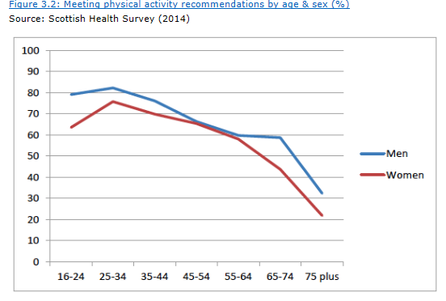  Adult (16+) 150 minutes moderate or 75 vigorous physical activity participation drops by age and is lower for women.  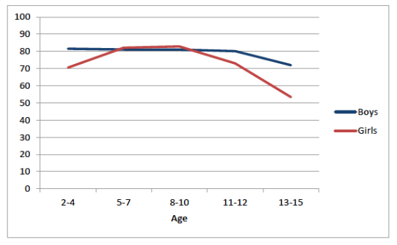  Young people (under 16) 60 minute/day moderate to vigorous activity/day highest age 5-10 at 82%, but drops to 63% by 13-15 and is particularly pronounced in teenage girls.  (Ref 2)  Older users are not ‘digital natives’ so are less likely to be completely comfortable with technology and digital communications. Complex user interfaces that assume a reasonable level of understanding of technology are likely to cause issues.  Older users may also be using older technology e.g. slower devices, lower resolution displays, older versions of browsers and slower internet connections. Therefore they may find it difficult to interact digitally. An example is where older users may prefer to fill out and post paper based forms rather than completing a submission online.  (PRENSKY, M (2001a), Digital Immigrants, Digital Natives) | Negative – Older adults are less likely than younger adults to achieve recommended activity levels and that is a major concern with an ageing population.  Our SFF application forms only ask for data on number of members/users Under 16 Male and Female and Adult Male and Female in current year and last 2 years and projections for next 3 years and therefore does not capture a full demographic profile of impact other than youth to adult trends and proportions.  As a result we may not be able to demonstrate we are making decisions which have the most significant impact on participation at different age bands in numerical terms. But we do look at what programmes and interventions applicants are or will make.  Positive Impact on younger people because:  - they are more likely to use sports facilities (given general participation trends)  - our expertise, advice and design guidance factors in child protection requirements and recommends ‘family friendly’ changing facilities  Potential positive impact on older people if:  - Changing facilities are family friendly so older people with caring responsibility for younger people are more likely to use  However, family friendly / village changing may also have potential negative impact on older people who anecdotally don’t like open and mixed changing as opposed to segregated male and female changing.  The current and updated SFF Guidelines will continue to require all applicants to demonstrate that their governance documents include an “Open to All” clause e.g. “Membership is open to all and no application for membership will be refused on other than reasonable grounds. There will be no discrimination on grounds of age, disability, gender reassignment, marriage and civil partnership, pregnancy and maternity, race, religion or belief, sex; sexual orientation, political or other opinion”  Older people are less likely to access the technological elements of learning and more likely to prefer face to face opportunities. | - In the Review of SFF consider changes to SFF application process to collect better demographic information on age and sex of members/participants/users to demonstrate and monitor impact of investment on different sectors of the population.  - Prioritise SFF applications for projects that target growth and new opportunities in particular for under-represented areas such as youth to adult, adult to youth, increase in younger or older participants or teenagers/young women to take part in sport.  - Consider if there are different design requirements for all different age groups in our facility design advice and guidance.  - Consider if there is a need for wider research and further evidence to consider facility barriers to access in relation to the target age groups.  - Provide guidance in different formats on request – mitigate impact  - Consider with internal colleagues in SD how to collaborate and involve Young People Sport Panel our facility planning, design and investment work
Disability | Disabled people are more likely to not take part in sport than those without a disability.  2011 Census data recorded that 20% of the population (1,027,872 people) have long -term activity-limiting illness health problem or disability and the prevalence increases with age. There are a wide variety of these as follows not just physical disability:  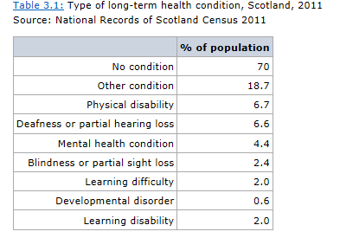  (Ref 2)  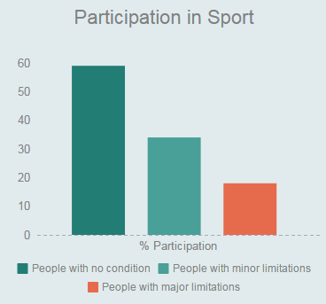  Participation also varies between those with minor (34%) and major (18%) limitations Ref 3  Disabled people are also less likely to use leisure facilities and when they do report lower levels of satisfaction (47% very/fairly satisfied) with local authority sport and leisure facilities than those with no disability (62%).  Literature suggests that disabled people themselves may feel self conscious, have low levels of confidence or fear of failure in relation to sports. . (sportscotland (2001) Sport and People with a disability: Aiming at Social Inclusion).  Intersectionality i.e. disability and age are strongly linked. An aging population means disability is likely to increase. | Positives: Of those people with a disability that do take part in sport, 45% take part frequently (15 days or more/month) which is almost equal to people with no disability at 49%.  Currently in the SFF applications we ask “As the service provider of a public facility you have a duty under the 2010 Equity & Inclusion Act to make reasonable adjustments/provision to ensure that disabled participants are able to use your facility. What steps have you taken to comply with this legislation?”  Potential positive impact on people with a disability because our expertise, advice and design guidance factors in access requirements and recommends all facilities are barrier free. Also where appropriate to provide and connect with the network of Changing Places.  Facilities Development team already works closely with Scottish Disability Sport on all design advice and guidance, and projects including the new fully inclusive Inverclyde National Sports Training Centre.  The current and updated SFF Guidelines will continue to require all applicants to demonstrate that their governance documents include an “Open to All” clause e.g. “Membership is open to all and no application for membership will be refused on other than reasonable grounds. There will be no discrimination on grounds of age, disability, gender reassignment, marriage and civil partnership, pregnancy and maternity, race, religion or belief, sex; sexual orientation, political or other opinion  Negatives: UK research found only one in four sports clubs thinks they have suitable sports facilities for disabled people to participate, appropriately trained staff and equipment. (Ref 1)  Note currently SFF Guidelines state ineligible projects include “works undertaken solely to comply with the requirements of the duty to make adjustments under the Equality Act 2010” This means that facility providers whether they be clubs or local authorities need to make reasonable provision to their existing facilities for access at their own expense. | - Where the need and impact is greatest and the outcomes are clear, prioritise SFF applications for projects that target new or enhanced provision for disability groups to increase participation or enable inclusive participation.  - Ensure the inclusive and different design requirements of all disability groups in our facility design advice and guidance goes beyond mobility e.g. sensory (blindness & deafness), learning, mental health etc and that this goes beyond the playing membership. The draft Accessibility Guidance already completed will be reviewed and updated to include guidance on equalities as well as family friendly facilities.  - SFF applicants should demonstrate evidence of consultation with local Access Panel and have an Equalities and Inclusion officer/champion.
Gender reassignment | Ref 1 Equality & Sport Research  Practical barrier cited by transgender participants suggests that the way facilities are laid out can present barriers. Therefore the availability of cubicle/private/gender neutral changing, showers and toilets rather than communal is preferred.  The Equality Network’s Out for Sport report on tackling transphobia in sport found that many trans people face transphobia and other barriers to participating in sport - 73% of survey respondents think transphobia is a barrier to sport.  The report also found that training should be developed for teachers and staff working in schools, clubs and elsewhere, on sexual orientation and gender identity issues including the identification, prevention and challenging of homophobic and transphobic bullying.  Equality and Sport Research suggests sports clubs, governing bodies and activity providers should take preventative steps towards bullying behaviour by:  •promoting safe environments which celebrate and embrace diversity  •having strong policies and procedures  •gathering information to assess the extent of problems  •raising awareness of issues  •raising the profile of LGBT sports groups and clubs  •increasing participation in all sports and physical activity  •using major events, like the Commonwealth Games, to educate and inform | Positive:  Potential positive impact.  Facilities Development team’s design advice and guidance already does promote taking preventative steps to provide appropriate facilities to avoid creating environments that could foster negative behaviours.  The current and updated SFF Guidelines will continue to require all applicants to demonstrate that their governance documents include an “Open to All” clause e.g. “Membership is open to all and no application for membership will be refused on other than reasonable grounds. There will be no discrimination on grounds of age, disability, gender reassignment, marriage and civil partnership, pregnancy and maternity, race, religion or belief, sex; sexual orientation, political or other opinion”  Negative:  Potential negative impact.  There is a lack of good data and information to inform this area of our work further. | 10. In our design advice and guidance promote awareness of the needs of LGBTI participants and examples of good practice in terms of the availability of cubicle/private/gender neutral changing, showers and toilets rather than communal.
Race | Ref 2  Majority of Scotland’s population is white, with 96% identifying as white within the 2011 Census, 4% or 210,000 people identify with a minority ethnic group & ethnic minority population is growing, from 2% in 2001 to 4%in 2011.  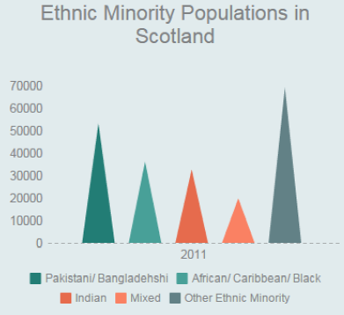  Additional analysis undertaken on Scottish Household Survey data from 2009 found that people who identified as ‘other British’ or ‘any other white background’ were more likely to participate in sport than other groups. Asian people were least likely to participate. Participation for those who identified themselves as Scottish was close to the average participation rates.  There is intersectionality between race and language – just over one per cent (73,000) of people aged 3 and over in Scotland were reported as being unable to speak English well or at all.  (National Records of Scotland, 2011 Census) | Negative: There is very limited data on participation by race. Race and religion and belief are both likely to influence participation negatively due to factors like racism and time and family or religious observation commitments differing from the majority of the Scottish population.  Potential negative impact if our investment forms/design guidance is not accessible due to a lack of English proficiency  Positive:  Through our investment guidance Clubs and facility providers have to consider that there may be particular requirements required to foster opportunities to increase participation from under-represented ethnic minorities.  The current and updated SFF Guidelines will continue to require all applicants to demonstrate that their governance documents include an “Open to All” clause e.g. “Membership is open to all and no application for membership will be refused on other than reasonable grounds. There will be no discrimination on grounds of age, disability, gender reassignment, marriage and civil partnership, pregnancy and maternity, race, religion or belief, sex; sexual orientation, political or other opinion” | 11. Continue to produce content using plain English and avoiding the use of jargon unless it’s appropriate to use for the specific audience. Ensure that digital content is accessible and standard compliant as this allows online translation services to parse the content and deliver auto translations.
Religion or belief | Ref 2  Current statistics show that as a nation, Scotland is ‘less religious’ than in previous years. Those who stated their religion in 2001 dropped by 11%.  54% of Scotland’s population identifies as Christian and c 37% as having no religion. Only 2.5% or 136,000 people identify with a minority religion or belief.  The number of people in Scotland who described themselves as having a non-Christian denomination was up by 80% to 77,000.  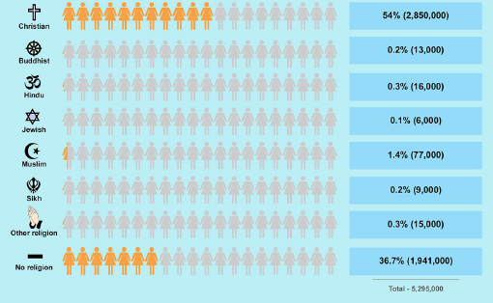  Race and religion and belief are both likely to influence participation with factors like racism and time and family commitments or religious observation differing from the majority of the Scottish population.  Information available suggests that people with Muslims faith are less likely to participate and particularly Muslim women. Barriers for these women include not being allowed to take part in mixed gender sport and also a strict dress code.  Positives: Those with no religion, who tend to be younger, are more likely to participate in sport. | Negative: As with Race there is very limited data or information on participation or facility issues for Religion or Belief.  Positives: Those with no religion, who tend to be younger, are more likely to participate in sport.  The current and updated SFF Guidelines will continue to require all applicants to demonstrate that their governance documents include an “Open to All” clause e.g. “Membership is open to all and no application for membership will be refused on other than reasonable grounds. There will be no discrimination on grounds of age, disability, gender reassignment, marriage and civil partnership, pregnancy and maternity, race, religion or belief, sex; sexual orientation, political or other opinion” | 12. In our design advice and guidance promote awareness of the needs of different religion and belief participants and examples of good practice in terms of the availability of multi-purpose/ prayer rooms, cubicle/private/gender neutral changing, showers and toilets rather than communal and importance of measures to ensure privacy from public view and that are safe and welcoming environments. Also programming where appropriate to allow participation.
Sex | Ref 2 2014 SHS Survey  More men – 57% take part in sport and exercise than women – 46%. This gaps starts as early as the age 13-15 were 71% of boys and 56% of girls take part in sport  Ref 1 Equality & Sport Research  Data for Scotland shows that women are less likely to be members of clubs, and more likely to take part in individual and non-competitive activities. This means that they are often participating outside the reach of sports governing bodies, through which most of the funding for sport comes. | Negatives: the demographic profile of club membership and sport facility usage may be reinforced by the stereotype of the statistics.  Our SFF application forms only ask for data on number of members/users Under 16 Male and Female and Adult Male and Female in current year and last 2 years and projections for next 3 years and therefore does not capture a full demographic profile of impact other than youth to adult trends and proportions.  Positives: In the SFF our governance checks ensure that club constitutions or memo and articles meet or will be changed to meet the equality and inclusion standards and do not discriminate on the grounds of sex and the facilities can be used by male and female participants.  The SFF current and future SFF Guidelines promote projects that make provision for women and girls. | 13. Change SFF application process to collect better demographic information on age and sex of members/participants/users to demonstrate and monitor impact of investment on different sectors of the population.  12. Ensure our design guidance promotes designs that are gender neutral to allow for maximum flexibility and prevent limitation on access eg. - move away from communal shower areas to cubicle/partitioned showers where appropriate.
Sexual orientation | Ref 1 Equality & Sport Research  There is very limited data on sexual orientation and sport participation or date on number of people who are lesbian, gay or bisexual but the estimate is 1 to 7% of the population.  Participation is not known to be significantly different from heterosexuals. However there might be under representation of LGBTI people in surveys as they are likely to only reflect those that are “out” and people (for personal reasons) often prefer not to share their sexual orientation with others.  Equality and Sport Research suggests sports clubs, governing bodies and activity providers should take preventative steps towards bullying behaviour by:  •promoting safe environments which celebrate and embrace diversity  •having strong policies and procedures  •gathering information to assess the extent of problems  •raising awareness of issues  •raising the profile of LGBT sports groups and clubs  •increasing participation in all sports and physical activity  •using major events, like the Commonwealth Games, to educate and inform | Negative:  As with Race there is very limited data or information on participation or facility issues for Religion or Belief.  Positive:  The current and updated SFF Guidelines will continue to require all applicants to demonstrate that their governance documents include an “Open to All” clause e.g. -“Membership is open to all and no application for membership will be refused on other than reasonable grounds. There will be no discrimination on grounds of age, disability, gender reassignment, marriage and civil partnership, pregnancy and maternity, race, religion or belief, sex; sexual orientation, political or other opinion” | - .In our design advice and guidance promote awareness of the needs of LGBTI participants and examples of good practice.
Pregnancy and maternity* | Nothing specific to this characteristic. | Positive in that in our design advice and guidance we recommend provision of facilities for feeding/changing babies. | Nothing specific to this characteristic.
Marriage/civil partnerships* | Nothing specific to this characteristic. | Nothing specific to this characteristic. | Nothing specific to this characteristic.
Socio-economic disadvantage | Ref 2 - Socio-economic Status (SES) does influence participation in sport. Scottish Household Survey 2014 shows variation in terms income levels and percentage of adults participating in sport in last 4 week (excl walking)  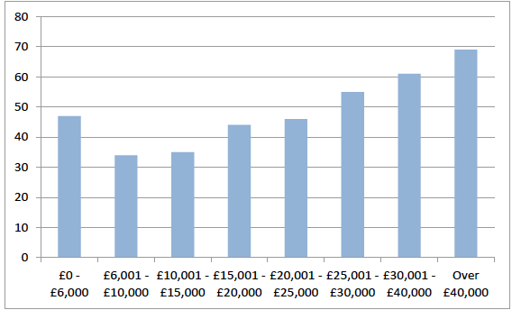  The gap in child participation in sport is also widening by SES. In 1998 the gap in participation between those from the most deprived compared to least deprived was 8%, in 2010 it was 15% and in 2014 it had increased to 21%.  There is no breakdown of attendance at LA leisure facilities by SES, but the 2014 SHS did find that attendance increased with increasing income, increased level of educational qualification and decreasing level of deprivation. Only 35% of those in most deprived areas had accessed leisure facilities in last year, compared with 43% in least deprived. 22% with an income less than £10,000 had accessed leisure facilities in last year compared with 55% for those earning greater than £40,000.  When walking is included in statistics there is very little difference in physical activity levels between adults and children in the most and least deprived areas.  SES is not the only factor that influences participation as this will also be impacted by protected characteristics like age, sex, etc. | Negative:  With potentially more limited SFF and LA budgets going forward it may difficult to prioritise applications in or serving SIMD areas there could be limited resources to make a significant impact.  sportscotland is unable to control the quality or where SFF applications come from.  Positive:  No internal / external data suggested that there is a lack of sports facilities in deprived areas.  Recent internal research of recent investment awards from SFF 2011-2016 found that 46% of awards were in/adjacent/within 1 mile of the worst 20% SIMD areas, and 25% were in rural areas.  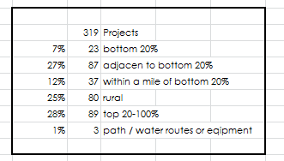  http://ssc-sharepoint/pl/i/IMP/sffnew/Awards%20and%20Budgets/SFF%202011%2020016%20SIMD%20review.xlsx  The current and future SFF Guidelines promote funding criteria that positively prioritises projects that in or serve the worst 10% of SIMD areas. Also continue to produce content using plain English and avoiding the use of jargon unless it’s appropriate to use for the specific audience. | - Consider doing some promotion / profile work to highlight facilities’ in SIMD areas to generate more applications?
Looked after children | Nothing specific to this characteristic. | Nothing specific to this characteristic. | Nothing specific to this characteristic.
*where policy is HR related

Who will be consulted internally on this EQIA?
Facilities Management Group - Mark Cowan, Graham Finnie, Steven Anderson, Lorraine Jones & David Ewart
Darren McKay – Strategic Planning
Mike Roberts – Head of Sports Development

Who will be consulted externally on this EQIA?
In planning external consultation please refer to the guidance on page five and speak to the strategic planning team for advice and support. It may be that there are several EQIAs that require external consultation at the same time and it is important this is coordinated.

What recommended steps should we take to improve the policy and monitor its equality impact?
In developing an action plan, project leads should balance how to maximise the positive impact of the policy or practice on all people who share the protected characteristics, with the requirement to maximise the core outcomes of the policy/practice (i.e. recommendations should be proportional and relevant.) The assessment should take steps to embed ways of monitoring the ongoing impact of the policy and practice.
Action | Responsibility | Timeline
Age / Sex  In the review of SFF, consider changes to application process to collect better demographic information on age and sex of members/participants/users to demonstrate and monitor impact of investment on different sectors of the population. | David Ewart | 31 March 2018
Age / Sex / Disability / SIMD  Prioritise SFF applications for projects that target under-represented groups, where the impact is greatest and contribution to outcomes is clear e.g. focus on areas of deprivation, girls/young women, new or enhanced provision for disability groups to increase participation or enable inclusive participation. | David Ewart | 31 March 2018
Age / Sex / Disability / Sexual orientation / Religion & Belief / Gender reassignment  Using industry best practice standards, ensure our facility design advice and guidance promotes the needs and specific requirements of people who share protected characteristics | Graham Finnie | 31 March 2018
Race / Age  Provide guidance in different formats on request, continue to produce content using plain English, and ensure that digital content is accessible and standard compliant. | David Ewart | 31 March 2018
Disability  The draft Accessibility Guidance already completed will be reviewed and updated to include guidance on equalities as well as family friendly facilities. | Graham Finnie | 31 March 2018
Disability / All  SFF applicants should demonstrate evidence of consultation with Local Access Panel and have an Equalities and Inclusion officer/champion. | David Ewart | 31 March 2018
SIMD  Consider profiling work to highlight facilities’ in SIMD areas to generate more applications. | Mark Cowan | 31 March 2018
Roll out this EQIA and links to Equalities Research to the Facilities Development team to raise awareness. | Mark Cowan | 31 March 2018

Sign off
Assessment signed off by: | Senior Management Team
Sign off date: | 16th May 2017

Best practice would involve gathering evidence through internal and external consultation.

