STRATEGIC DOCUMENT

Business plan

sportscotland business plan 2023 onwards

Introduction
Our business plan for 2023 onwards describes how we will deliver our commitment to our corporate strategy, Sport For Life. It outlines how we will continue to support the sporting system to respond to the current economic challenges and drive inclusion and recovery. Appendix one shows how we will manage and report on this plan. Appendix two shows our draft projected income and expenditure for 2023-24.

Overview
Vision
An active Scotland where everyone benefits from sport
Outcomes
We improve opportunities to participate, progress and achieve in sport
We support wellbeing and resilience in communities through physical activity and sport
We encourage and enable the active to stay active throughout life
We improve our active infrastructure – people and places
We encourage and enable the inactive to be more active
We develop physical confidence and competence from the earliest age
Mission
Helping the people of Scotland get the most from the sporting system
Principles
Inclusive – We understand the barriers people face and proactively address them so everyone has the opportunity to get involved in sport and physical activity.
Accountable – We plan well, we measure our performance and we are accountable for delivering outcomes.
Responsive – We adapt what we do based on how we’re doing and what’s happening around us.
Person centred – We listen to people and put their voices at the heart of our thinking.
Collaborative – We develop and strengthen partnerships and collaborations across the public, voluntary and private sectors.
World class – We do everything to the highest possible standard, while seeking to continuously improve.

Strategic context
Our vision is of an active Scotland where everyone benefits from sport.
We are committed to the Scottish Government’s vision of a more active Scotland and the Active Scotland Outcomes Framework, which contributes to the National Performance Framework.
The Active Scotland Outcomes Framework describes Scotland’s ambitions for sport and physical activity. By adding value through investment, partnership working, influence and direct delivery, we lead the sporting system to contribute to all six Active Scotland outcomes:
- We improve opportunities to participate, progress and achieve in sport
- We support wellbeing and resilience in communities through physical activity and sport
- We encourage and enable the active to stay active throughout life
- We improve our active infrastructure – people and places
- We encourage and enable the inactive to be more active
- We develop physical confidence and competence from the earliest age
In addition, the Minister for Public Health, Women’s Health, and Sport issues sportscotland with a strategic guidance letter, which includes a set of Ministerial priorities. To deliver on our 2022-26 strategic guidance letter, we will:
- Focus on reducing inequalities in sport and physical activity. This should include work to:
  - Tackle racism and racial inequality in sport.
  - Reduce cost barriers to sport.
  - Increase participation and visibility of girls and women in sport.

- Work with partners to provide accessible and inclusive opportunities for children and young people to be active in the schools & education environment. This should include work to:
  - Ensure that the Active Schools programme is free for all children and young people by the end of this parliament.
  - Work with key partners to contribute to the development and delivery of Physical Education, Physical Activity and Sport (PEPAS), as part of the Health and Wellbeing curriculum.
  - Support schools with water safety and learning to swim.

- Support sports clubs and community organisations to provide accessible and inclusive sport and physical activity opportunities. This should include work to:
  - Strengthen Community Sport Hubs.
  - Work with communities and key partners to facilitate and support the provision of accessible, inclusive, and sustainable facilities.

- Place inclusion and welfare at the centre of the high-performance sport environment that prepares and supports athletes to deliver consistent success on the world stage. This should include work to:
  - Support a diverse and inclusive performance sport environment.
  - Prioritise the welfare of athletes and others involved in performance sport.

- Provide leadership to develop and sustain strategic partnerships that help sportscotland to deliver your vision, including partnerships with non-traditional partners.
Our corporate strategy, Sport For Life, and this strategic guidance are the key strategic drivers for our business plan.

A sporting system for everyone
Our mission is to help the people of Scotland get the most from the sporting system.
The sporting system is made up of different components that interact with each other as illustrated in the diagram below. It shows how resources are invested by various organisations (partners) to promote sport and develop the people and places that create sporting opportunities which are delivered in the schools and education, clubs and communities and performance sport environments.
It helps everyone see where they fit in and how they contribute. As a result, people in Scotland take part in sport at the level they choose which has an impact on activity levels, health and other aspects of society and the economy.
Figure 1: Scotland’s world class sporting system
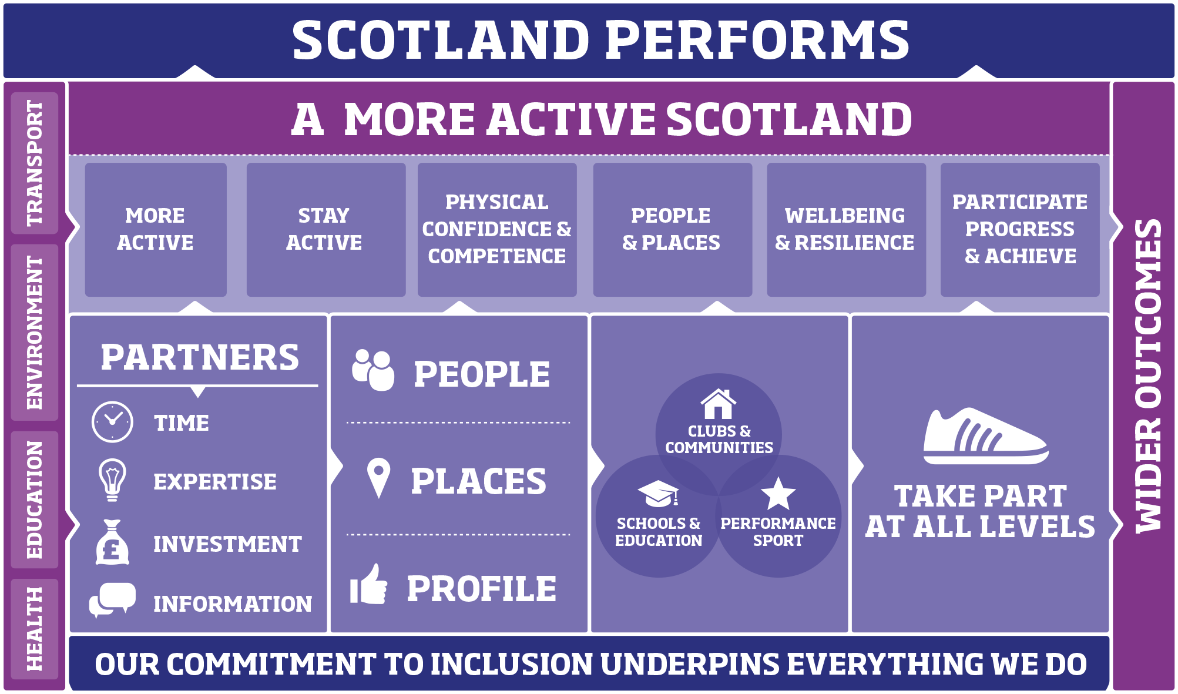

Responsive recovery
We recognise economic and cost-of-living pressures are resulting in significant challenges across the whole sporting system. Against the backdrop of recovery from the pandemic, the current crisis may have an even greater impact given the reduced capacity and resource across the system to respond.
One of the principles in Sport For Life is to be responsive. We need to adapt what we do based on what’s happening round us. As the world and society around sport changes, the sporting system components and the way they interact also needs to evolve.
We are committed to supporting our partners through this crisis, with inclusion at the core of our decision making. Our work through the Strategic Forum for Sport and Physical Activity is vital as we look to collectively drive long-term recovery, sustainability and consistent messaging for the sector. Alongside our work with the Strategic Forum, we provide strategic leadership to the sport and leisure sector, driving collaboration across a wide range of partners including the Scottish Government, Public Health Scotland, Transport Scotland, Education Scotland, COSLA, SOLACE, VOCAL, Community Leisure UK (Scotland), local authorities and local partners, SGBs, higher and further education institutions and third sector organisations.
With this context in mind, through this plan we will do everything we can to safeguard and protect the current professional workforce that our investment supports and to maintain the wider infrastructure that the sporting system is built on.

Inclusion underpins everything we do
Inclusion remains our primary organisational priority.
We know that sport has a major role to play in tackling inequality and contributing to a more inclusive Scotland. We provide leadership to the sporting sector, to influence and drive the changes needed to reduce inequalities and ensure everyone has the opportunity to take part in sport and physical activity.
We also know that recovery from the harms caused by the pandemic are not being felt equally. Before the pandemic certain groups of people were less likely to take part. They are also the most at risk of worsening inequalities due to the cost-of-living crisis. We must be responsive to their needs.

Our approach to equality, diversity and inclusion
Sport For Life, sets out the direction for sport and sportscotland. It celebrates how everyone in Scotland can benefit from sport. It sets out our commitment to inclusion underpinning everything we do.
Our equality, diversity and inclusion (EDI) approach brings to life this underpinning commitment through three strands aligned to the Public Sector Equality Duty (PSED). Our approach is about ensuring equality, diversity and inclusion is embedded in all our work. It will become our business as usual.

Figure 2. Three strands form our equality, diversity and inclusion approach
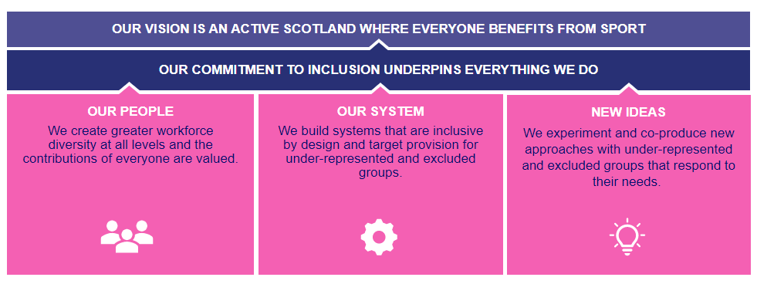

Our people
We will lead by example by embedding equality, diversity and inclusion in the recruitment, support and development of “our people”.
We will learn more about our culture and people’s experiences. We will support our staff and networks to learn more about how to make inclusive decisions.

Our system
We will aim to debias mainstream systems and processes. We will look at how we do things, as well as the activities we do. Our system will be inclusive by design.
We will strengthen our continuous improvement process. We will build on the networks and learning from our previous outcomes to inform our mainstream work. We recognise women and girls, disabled people and those living in areas of high deprivation are part of the diversity of the new focus groups outlined in the new ideas strand.
We continue to grow and share our equality data and evidence, through examples such as Tackling Racism and Racial Inequality in Sport research. We use this insight to aid decision making and help us all take action. This can include additional, targeted support to reduce inequalities for specific disadvantaged or under-represented groups.

New ideas
- We will deliver our equality outcomes through the “New ideas” strand. We have set person-centred, thematic outcomes to reach these groups in a way that recognises their diversity.
We will test new ideas, co-produced for and with excluded groups, to tackle pressing inequalities in sport. We will be prepared to fail and learn. Our work will evolve as we learn.
We will involve excluded groups from “start to finish” in the decision making. Our actions will be based on their diverse needs.
We will phase the delivery of our new ideas over the period of this plan, ensuring we progress work with our diverse ethnic communities in the first instance.

Additional areas of responsibility
The following additional areas of responsibility also help us deliver the PSED:
Mental Health Charter for Physical Activity and Sport: As a Charter signatory, we aim to improve equality and reduce discrimination for anyone with a mental health problem taking part in sport.
Corporate Parenting: As a Corporate Parent, we have a responsibility to understand and respond to the needs of care-experienced young people as any parent should.
Rural disadvantage: People in rural areas can find it difficult to access sport because of limited public transport, or fewer opportunities than urban areas.
You can find out more about our EDI approach at: Sport for Life and our approach to Equality, Diversity and Inclusion (sportscotland.org.uk)

Sport and climate change
We understand that climate change will have wide ranging impacts across all aspects of society. The sporting system is not immune to these. The continuing effects of climate change are well documented, with extreme weather increasingly likely to impact when and where sport and physical activity takes place. Sport is also a contributor to climate change and can have other negative impacts on the natural environment, for example through energy consumption and emissions, travel and transport, and facilities infrastructure.
We recognise more work is needed to establish the specific actions required to have the greatest positive impact on climate targets and environmental sustainability, with our commitment to inclusion at the core. We will work with the Scottish Government, other home countries, UK Sport, the British Association for Sustainable Sport, Zero Waste Scotland and other partners to guide joined-up efforts across the sector. This will provide a platform in the future for shared work in areas such as learning and development.

Making an impact together
We understand the importance of partnerships and partnership working, and how dependent a world class sporting system is on this approach. We recognise and value the strong relationships we currently have with a wide range of partners who invest a significant amount of their time, expertise and investment into sport and physical activity.

Strategic partnerships
We know that the sporting system makes a significant contribution to the delivery of the Active Scotland Outcomes Framework. However, we also recognise there needs to be a broader set of partners, such as those responsible for education, health, environment, transport, and local government, contributing individually and through effective partnership to achieving the Active Scotland outcomes.
We will continue to take a confident leadership and enabling role, driving existing and new partners in the sporting system to work together to make a greater contribution to these outcomes. We will focus on developing strategic relationships with Public Health Scotland, Transport Scotland and Education Scotland as part of a collective cross-sector approach, in line with the wider Active Scotland Delivery Group, to help improve outcomes for communities and deliver the shared vision of a more active nation. The 2023 UCI Cycling World Championships taking place in Glasgow and across Scotland this year provide a strategic opportunity for agencies to collaborate with the aim of making the nation more active.

Delivery partnerships
We have strong and embedded relationships with all 32 local authorities and other local partners, including leisure trusts. We invest in 48 Scottish governing bodies of sport (SGBs), providing additional support and expertise to many more. We want to develop stronger partnerships and connections between these local and national partners, as well as partners in the third sector, to enable them to look to the future and collaboratively plan the recovery of sport and physical activity with inclusion at its core.
To do this, we are committed to improving the way we work and being flexible and agile over how we allocate our resources. This will enable us to add the greater value to partners, better meet the needs and aspirations of local communities, and work collectively to achieve a greater impact on local and national outcomes.
We have a key role to play in driving the sporting system to engage those who are not yet involved. We will continue to work with existing and new partners to explore ways our mainstream services can become more inclusive and to identify where targeted approaches are needed to reduce inequalities.
We have developed a positive, collaborative partnership with the Scottish Association for Mental Health (SAMH) to support the sector to better understand the value of sport and physical activity and its contribution to positive mental health and wellbeing. Our developing relationships with Sporting Equals, ENABLE and Scottish Disability Sport will help support the aims and delivery of our EDI approach as well as our targeted work in key local areas with local and national partners. We will continue to identify, grow and develop new partnerships with other organisations from within and out with the sport sector. This will help develop stronger connections across the environments and achieve greater impact.
We continue to identify and support improvements to planning for sport, with a focus on further developing how we and our partners gather, share and use data to plan and deliver more effectively. We will also maintain a focus on supporting partners to take a more integrated and strategic approach to planning for sport, that considers the contribution of people and places.

Organising our work

The environments
We use the environments in the sporting system to structure the programmes, and objectives in our business plan. Our people, places and profile objectives are embedded within each environment. We also integrate our operational support and the activity of the sportscotland National Centres Inverclyde and Glenmore Lodge where possible.
Strengthening the connections between the National Centres and our local and national partners’ planning and investment processes has the potential to add significant value to delivering outcomes and our work on inclusion.
We believe this structure ensures we channel our time, resources, and investment in the best possible way to support the sporting system to drive inclusion and recovery while protecting key system infrastructure.

Our people
Our people are a major asset. They have significant talent and energy and are committed to improving sport and physical activity in Scotland. Our ambition is to add more value through our people. We will explore more innovative, targeted use of our staff resource with partners to ensure we achieve a greater impact on our shared outcomes. The continued activation of our new people strategy will drive the development and investment into our staff.

Action plans
Each programme in our plan is underpinned by an action plan. These outline the key actions we will deliver to achieve our priorities and programme objectives. They also include the people responsible and the budget we have allocated.
Figure 3: Our approach to operational planning
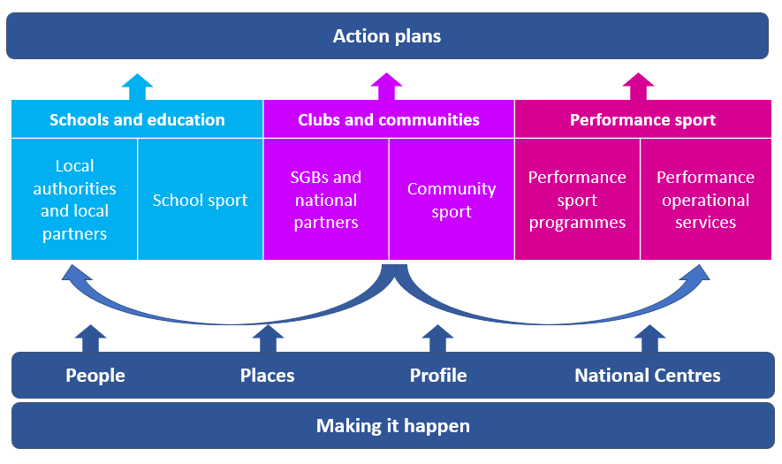

Schools and education
The schools and education environment helps build competence and confidence in sport by providing positive sporting experiences at schools, colleges and universities.
This plan aims to build on the progress we have achieved with local and national partners in schools and education. We will collaborate closely with local and national partners to make changes to improve sport and physical activity for children, young people and young adults.
We will continue to hold strategic conversations with local authorities and local partners to understand the impact of the cost-of-living crisis and resource constraints on local sport and physical activity.
We will use our partnership working to everything we can to protect the professional workforce and sports facilities infrastructure, while driving the changes needed to reduce inequalities and ensure inclusion underpins everything we do. Our support will be driven by the needs and priorities of our local partners.
Programme | Objectives
Local authorities and local partners | We will:  - strengthen and develop our partnerships with local authorities and local partners, and support and invest strategically in them to deliver against ASOF, inclusion and wider outcomes that meet local need.  - build capacity and improve the quality and diversity of the workforce based on the needs of local partners.  - work with local authorities and other partners to ensure the best use is made of places for sport.  - encourage greater collaboration between local partners and our National Centres with a focus on local priorities for inclusion.  - work in partnership with the college sector to increase sport and physical activity opportunities for students and enhance the approach to work-based placements in sport.  - raise the profile of the work of our local authorities and local partners and celebrate the impact it has on people and communities.
Programme | Objectives
School sport | We will:  - provide leadership to Active Schools and the Active Schools workforce to support them to be more inclusive and targeted in their work.  - build capacity and improve the quality and diversity of the workforce based on the needs of Active Schools.  - support the development of effective pathways between schools and sports clubs in the local community.  - provide targeted support and investment in the school, college, and university estate.  - raise the profile of the work in school sport and celebrate the impact it has on people and communities.

Clubs and communities
The clubs and communities environment offers local opportunities for participants and athletes to take part in sport and physical activity and develop to the level they choose.
This plan aims to build on the progress we have made with local and national partners in club and community sport. Through our ways of working, we will improve the connections between local authorities and SGBs to build capacity and capability within local clubs, hubs and communities. We will work with third sector organisations and other partners to add value and strengthen this approach.
We will continue to work with SGBs, national partners, clubs and community organisations to understand the impact of the cost-of-living crisis. We will work with partners to target our investment to help protect the professional workforce and sports facilities infrastructure, and support the ongoing recovery of the sport and leisure sector.
We will encourage a more inclusive approach and support clubs, hubs and communities to understand and adapt to better meet these requirements.
Programme | Objectives
SGBs and national partners | We will:  - strengthen and develop our partnerships with SGBs and national partners, and support and invest strategically in them to deliver against ASOF, inclusion and wider outcomes that meet their needs.  - develop partnerships with third sector and EDI expert organisations, and support and invest in them to achieve shared outcomes.  - build capacity and improve the quality and diversity of the workforce based on the needs of SGBs and national partners.  - work with SGBs to encourage and support them to take a more strategic, integrated and sustainable approach to places.  - encourage greater collaboration between SGBs and national partners, and our National Centres with a focus on inclusion and performance pathway development.  - raise the profile of the work of our SGB and national partners, and celebrate the impact it has on people and communities.
Programme | Objectives
Community Sport | We will:  - align our people and capital investment resources to ensure more people can benefit from an enhanced club, hub and community sport offer, specifically in areas of multiple deprivation or rural disadvantage and where gaps in provision and local opportunities exist.  - develop a network of inclusive Community Sport Hubs that improve the contribution of sport and physical activity in a community, specifically in areas of deprivation and where gaps in provision and local opportunities exist.  - build capacity and improve the quality and diversity of the workforce based on the needs of clubs and community sport hubs.  - encourage more inclusive practice through the training and development of the professional and voluntary workforce across the environments, aligned to our EDI approach.  - provide targeted support and investment in places for clubs, community sport hubs and community organisations.  - support clubs and community organisations who are considering taking on the management or operation of a sports facility.  - raise the profile of the work in club and community sport and celebrate the impact it has on people and communities.

Performance sport
The performance sport environment helps prepare and support athletes to perform consistently on the world stage using cutting edge expertise and technology.
This plan aims to build on the progress we have achieved within performance sport in partnership with SGBs and others.
We will continue to enhance areas of our system in response to the changing landscapes and direct requirements of our sports, athletes and partners..
We will continue to provide and encourage better leadership, management and impact awareness across our high performance system through refining our management toolkits and ensuring athlete and staff welfare is at the core of our programmes and support. We will use research, data and business intelligence to ensure we can make better informed decisions going forward.
Programme | Objectives
Performance sport programmes | We will:  - support and invest strategically in Scottish and British governing bodies to deliver outcomes targeted at the:  - Paris 2024 and Los Angeles 2028 Summer Olympic and Paralympic Games.  - Milan Cortina 2026 Winter Olympic and Paralympic Games  - Victoria 2026 Commonwealth Games.  - lead Scottish and British governing bodies to implement sustainable performance systems in their sport.  - deliver targeted initiatives to enhance the Scottish performance system to achieve sustainable success.  - drive a culture of effective learning and improvement for internal and external people working in high performance sport  - lead the development of more inclusive and sustainable performance pathways, underpinned by a system approach to talent development.  - showcase how our High Performance system is delivering consistent success on the World stage, adding value to athletes, programmes and SGBs as the team behind the team.
Performance operational services | We will:  - deliver innovative expertise and agreed performance support services to targeted sports and athletes, to ensure we support them to work towards major Games.  - develop and strengthen our internal environments and our connections with key partners in sport to enhance the Scottish performance network.  - develop a data strategy to support operational service delivery and implement a data management system to support this.  - increase knowledge and understanding of health and welfare to support athlete and staff wellbeing across the Scottish performance system.  - oversee and manage a Clean Sport System in Scotland that maintains the integrity of sport and protects the rights of clean athletes.  - continue to develop our ways of working to support the effective and efficient delivery of our expertise across the Scottish Performance system

Making it happen
The programmes in this section are about effective business management. They support our work in all three environments, both within sportscotland and for the whole sporting system. They help us:
- make the most our people, places and tools.
- do the things we need to do to be a good organisation.
- help people understand and value us and sport.
Programme | Objectives
Making the most of our assets | We will:  - help recruit and induct staff, ensuring we have a competent, flexible and diverse workforce.  - retain and reward staff to sustain capability, capacity and agility.  - develop and support staff to make sure we have the skills and competencies we need.  - develop excellent managers and leaders who can deploy our resources effectively, ensure people are clear about their roles and empower them to deliver.  - continue to evolve our hybrid working model and reshape our office provision to meet longer-term requirements and support a new post-pandemic way of working.  - ensure our IT and digital infrastructure facilitates efficient and effective operations and is fit for the future.  - develop and maintain software to meet our needs and support staff to use it.  - provide a collaborative, healthy, safe and efficient work environment, which treats everyone fairly and with respect and continue supporting the overall physical and mental health and wellbeing of our staff.  - manage the corporate and regional office estate to ensure it is fit for purpose and meets the needs of the business.
Delivering with integrity | We will:  - deliver our equality, diversity, and inclusion approach.  - develop an integrated climate change and environmental sustainability approach to support the sector and reduce our internal impact.  - provide timely, reliable and consistent expert support on budget management, financial management and reporting, governance, payroll, procurement, legal and integrated investment.  - ensure appropriate cyber resilience measures are in place to protect our systems and data.  - deliver business and longer-term planning, and corporate performance reports.  - add to the evidence base about sport and help staff and partners use data to plan and deliver.  - explore a corporate data strategy.
Raising profile | We will:  - drive, deliver and support communications across the sporting system to inspire and support recovery, and provide strategic media advice and expert crisis communications support.  - celebrate and raise the profile of Scottish sport and promote opportunities for people to take part.  - lead our engagement with Scottish Government and local and national politicians.

Appendix one – Managing and reporting on this plan
This business plan and operational plans are a key component of our approach to planning, which is in Figure 4. It shows the connection between individual work plans, our business plan, our corporate strategy, the Active Scotland Outcomes Framework and the National Performance Framework.
All operational plans are held in Pentana, our corporate performance management system. We use this to produce quarterly reports on our progress for the sportscotland Board and Scottish Government based on the activity in this plan.
Figure 4: Planning approach
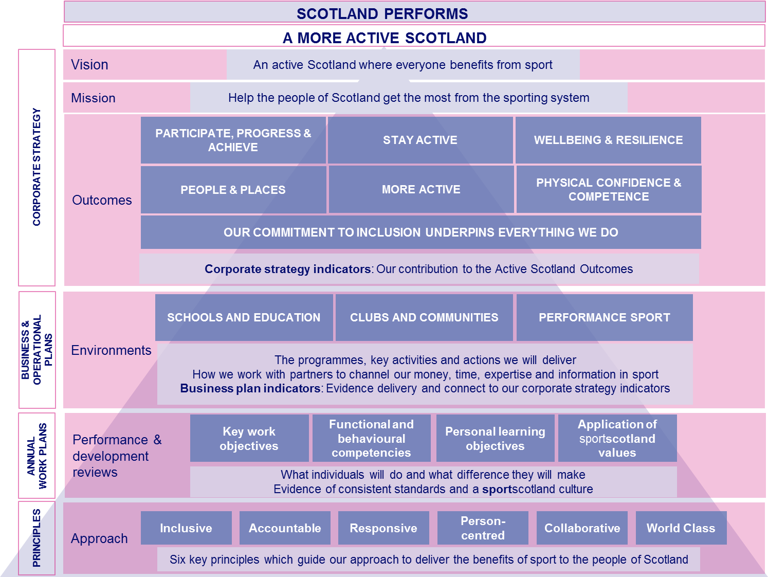

Performance measurement framework
Measuring performance helps us stay on track and show our impact. Our performance measurement is one way we do this.
Our corporate strategy indicators are long term indicators that show our contribution to the Active Scotland Outcomes Framework. These short, simple measures which show our impact will be kept the same until we refresh our corporate strategy.
Given the impact of the COVID-19 pandemic on our partners’ operations and the sporting system, we will prioritise capturing the scale and diversity of those taking part in our programmes as well as the impact of/recovery from COVID-19 pandemic.

Figure 5. Corporate strategy indicators
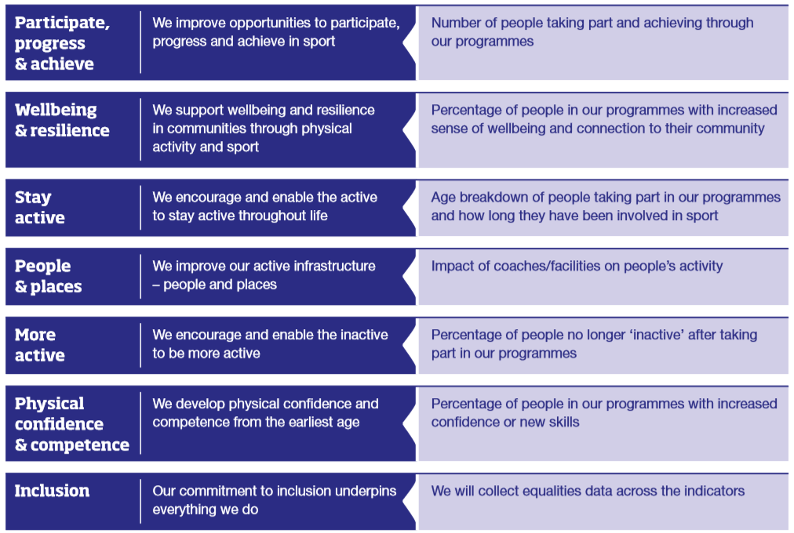

Lead Office
Doges, Templeton on the Green,
62 Templeton Street,
Glasgow G40 1DA
Tel 0141 534 6500

sportscotland.org.uk

http://nationalperformance.gov.scot/
https://www2.gov.scot/About/Performance/scotPerforms/partnerstories/Outcomes-Framework
https://sportforlife.org.uk/
https://sportscotland.org.uk/about-us/equality-diversity-and-inclusion/new-ideas-our-equality-outcomes/

