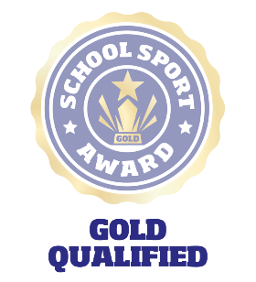
School Sport Award
A framework for school sport
School Details
School name:
School roll:
School lead name:
Active Schools Coordinator:
Social media links:
School Context – tell us anything else about your school (e.g. geography, size, ethos, etc.)...

Submitting For Gold
This is an opportunity for your School Sport Committee to reflect on their role over the last year and share their story with us.
Step 1: Complete the “School Details” above.
Step 2: Make sure your Action Plan is up to up to date
Step 3: Answer the three questions below. This can be through video (max 1 minute per video) PowerPoint, sway, Word, via your YouTube / Twitter, or any other method that works for you and your committee. Be creative – this is about telling your story!
Step 4: Upload your additional information, or if linking to external content, copy the links into this document and upload to your awards page.
Step 5: Submit for Gold!

Questions to answer

- What makes your school gold?
- What is something you have changed, and how?
- What is the best thing about sport in your school?

